MISSOURI WINEMAKING SOCIETY
SEPTEMBER 2021 NEWSLETTER

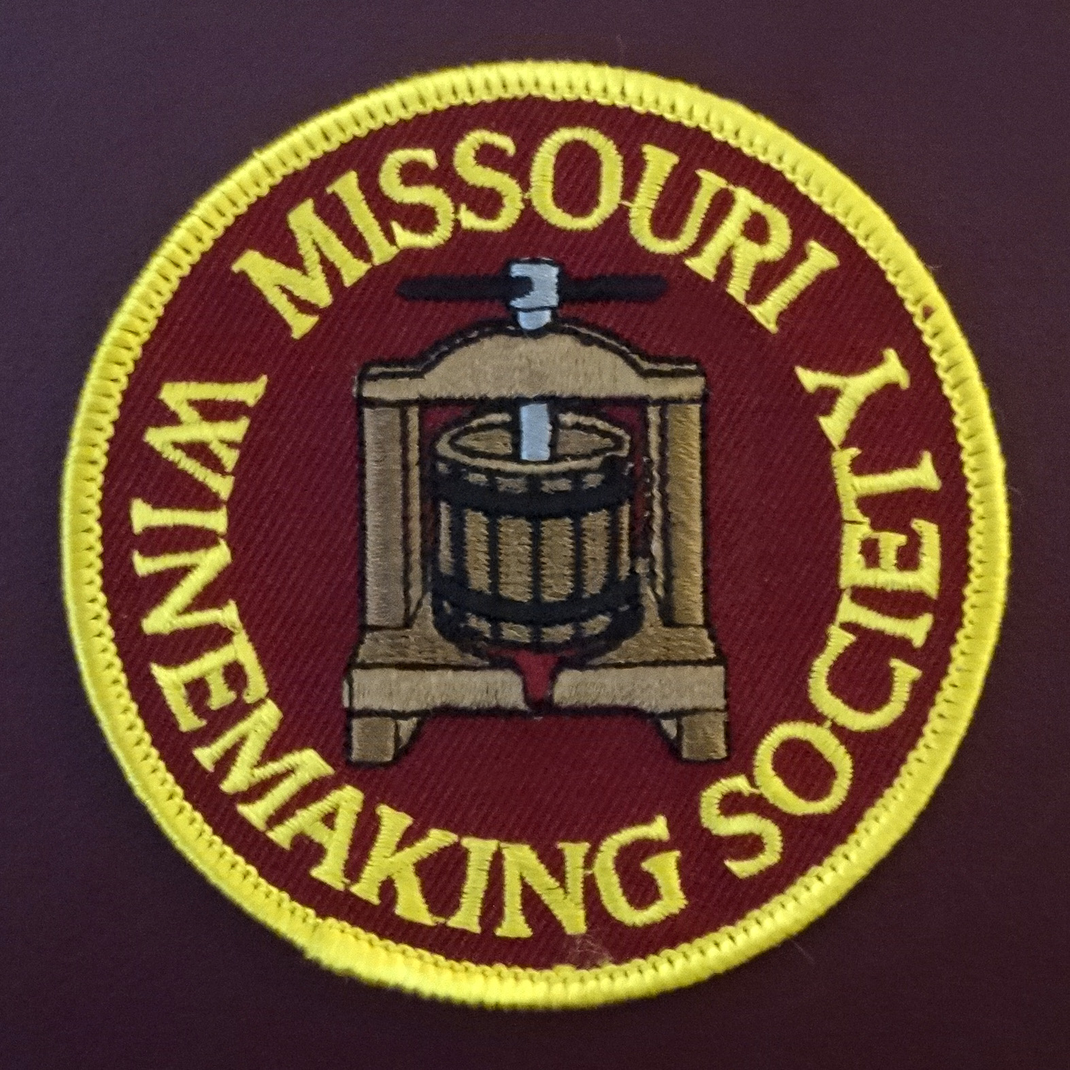

IN THIS NEWSLETTER:
- ZOOM … Wine Competitions….how to….
Thursday, 9/16 at 7:00 PM…Leader Greg Stricker
- PRESIDENT’S MESSAGE
Trying Something New
- CONGRATULATIONS Competition Winners
Greg Stricker, Steve Brunkhorst, Lisa Nordmann
- MEETING SCHEDULE FOR 2021
September meeting now a ZOOM
- AUGUST MEETING RECAP
Winemaking 2021…Members Share Knowledge…
- ODDS AND ENDS
Yeast Resources and Free Winemaking Gear…
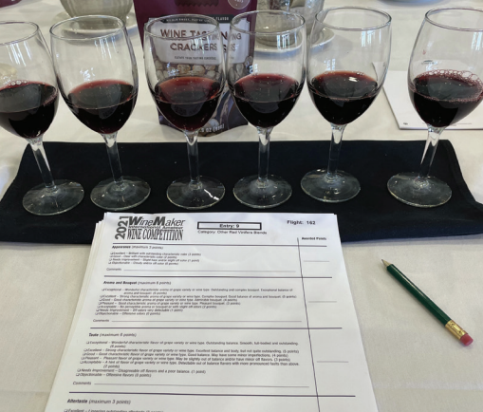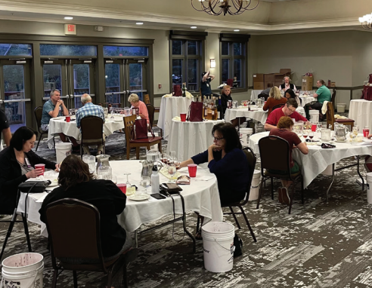

WE WILL ONCE AGAIN ZOOM IN SEPTEMBER. Your MWS officers reviewed the member survey, CDC guidelines, and St. Louis County Council disfunction to reach this decision.
Officers, I have contacted Greg Stricker and he will send some info to me about his presentation. I will incorporate that and then send out the newsletter.
For future meetings, the officers will review the situation each month to determine the meeting location and communicate that in the monthly newsletter. Our October gathering will be the annual picnic on Saturday October 16th at Dave & Debbie Wert’s home where there is plenty of space for safe gathering. We do have a room reserved at St. Gerard Majella for November 18th if the situation allows an in-person meeting.
PRESIDENT’S MESSAGE. By Lisa Nordmann
Lisa’s Thoughts: Trying Something New
I had my 2021 white wine making strategy all planned out. Recently, I took a boot camp with Winemaker Magazine and asked a question to the panel, “is preemptive fining a rule of thumb”? Allison Crowe emphatically said, “NO!” What??? She then said her winery only does whole cluster pressing with their whites and there really was no need for preemptive fining. She proceeded to explain that whole cluster pressing limits the extraction of phenolics and bitterness, which lessens the need for preemptive fining. Perfect, I thought. No more preemptive fining. I researched whole cluster pressing and fell in love with the process.
Early Sunday, I got everything ready. The Cayuga and Seyval Blanc grapes were chilled and waiting in my wine room. I sanitized my bladder press and all buckets. I had my metabisulphite and Llazyme Cmax right by my side. We tossed in the first 25 lbs of Cayuga whole clusters into the bladder press and away we went. The first press gave us ¼ gallon of juice. How can this be? Only ¼ gallon for 25 lbs? The next whole clusters were ready to go in. We got another ¼ gallon of additional juice. This was becoming too much work for so little juice, which took almost 45 minutes. At this rate, with 500 more lbs to go, we would be pressing whole clusters all day and night and getting little juice.
We needed to implement Plan B immediately. Cursing Allison Crowe and whole cluster pressing, we got the crusher destemmer out of the shed, hosed it down and sanitized it. We continued our day of crushing and destemming and immediately pressing. We finally finished with everything plus clean up at 5:00. All the juice was sulphited and Cmax was starting to settle the juice. I put all the filled carboys in their prospective corners (wine room and refrigerator) for settling.
After settling the juice and racking off the gunk, preemptive fining was next on my list of things to do, which I have had great success with. Currently, the juices are being fined with Bentolact S, which helps with bitterness and oxidation. I plan on letting the juices settle until this weekend when I will start my fermentation.
I will say, I am very thankful for that boot camp and Allison Crowe. I never would have tried something new if it was not for her. Yes, it was an epic failure. But at least I tried something different. As winemakers, we all make mistakes, and every one of them should be a learning process. And always remember, if you ask 5 winemakers how to do something, you will get 10 different answers.
Cheers! Lisa

CONGRATULATIONS TO Steve Brunkhorst, Lisa Nordmann, Greg Stricker!
Three MWS members medaled at the Winemaking Magazine's Wine Competition, congratulations to all!
Steve Brunkhorst won a Gold for his 2019 Washington State Chardonnay and a Silver for his 2019 Norton Port
Greg Stricker won a Gold for his 2019 Sauvignon Blanc/Semillion/Vignoles Blend, Silver for his 2020 80%Vignoles 20% Viognier, Bronze for his 2020 - 45% Sauvignon Blanc/40% Semillon/ 11% Vignoles and a Bronze for his 2020 -100% Chambourcin Rose'.
Lisa Nordmann won a Silver for her 2019 Norton, a Bronze for her 2020 Vignoles, Bronze for 2020 Chardonel, Bronze for 2019 Chambourcin/Norton Blend, and a Bronze for 2018 Chambourcin/Norton Blend
ALSO Greg’s wines earned recognition at the New Jersey State Fair. A Gold Medal and Best White Award for his 2019 Riesling, Double Gold for his 2020 Seyval, Gold Medals for his Chardonel, Traminette and White Blend. Also 5 Silver and 2 Bronze. The competition was judged by American Wine Society Certified judges.
2021 MEETING SCHEDULE. Please mark your calendar for the 3rd Thursday of each month at 7PM. The Current plan follows, officers will review the situation each month to determine if in-person or ZOOM meetings will be held. Check our website for real time updates of the MWS calendar: https://www.mowinemakers.org/
January 21 • 7:00 PM • Speaker • Andrew Meggitt - St. James Winery
February 18• 7:00 PM • Speaker • Kevin Kourofsky • Judge Judy Kelly • Make Better Wine
March 18 • 7:00 PM • Speaker • Hildegarde Heymann, Ph. D. Enologist UC-Davis
April 15 • 7:00 PM • Speaker • Jacob Schneider - Cane Pole Vineyards, LLC
May 20 • 7:00 PM • GADs & GIZs • John Merkle & MWS members
June 17 • 6:30 PM • Lisa & John Nordmann’s Home • Rose’ Winemaking Project
July 17 • 11:00 AM • Defiance Ridge Winery Tour and Picnic • MWS Members • Purchase Wine and Food there.
POSTPONED August 19 • 7:00 PM • Thursday • St. Gerard Majella • Program • Grape growing in Missouri, is Organic Possible? • Presenter • Terry Stromberg
August 19 • 7:00 PM • Thursday • ZOOM • Program • Winemaking 2021, grapes, fruit, juice, plans • Presenter Lisa & Officers & Members
September 16 • 7:00 PM • Thursday • St. Gerard Majella • Favorite White Wine Contest • Leaders • Steve Brunkhorst and Phil Rahn
September 16 • 7:00 PM • Thursday • ZOOM • Program • Wine Competition or Best Practices • Leader • Greg Stricker
October 16 • Noon • Saturday • Dave & Debbie Wert’s Home • Annual MWS Picnic • MWS Members Potluck
November 18 • Thursday • 7:00 PM • St. Gerard Majella • Favorite Red Wine Contest • Leaders • Steve Brunkhorst & Phil Rahn
December 11 • Saturday • 7:00 PM • John & Mary Merkle’s Home • Christmas Party • MWS Members Potluck
January 20, 2022 • Thursday • St. Gerard Majella • Missouri Gold Medal Winning Wines
RECAP: THE AUGUST 19th ZOOM TOPIC was “Winemaking 2021”. Members shared their estate vineyard experience and winemaking plans. There was an abundant exchange of experienced based information among members, and it felt like a very worthwhile meeting as we get ready for fermentation.
ODDS & ENDS:

Jerry Parker, a former member of Missouri Winemaking Society has generously donated items for our members. They are FREE and being stored at Lisa Nordmann's house. Here are the items:
4 - 5 gallon carboys
1- 3 gallon carboy
6 - 1 gallon jugs
Fruit mesh bag
Various size of bungs and solid bungs
15 air locks
25' Standard airline tubing 7.62m
4 oz Oak Chips
10kg French Oak Chips
A big thank you to Jerry Parker!
Contact Lisa Nordmann at lnordmann@sbcglobal.net
**************************************************************
IF ANYONE IS INTERESTED in purchasing some FT CITRUS (Scott Labs) please e-mail me at lnordmann@sbcglobal.net. I had to buy 2 1/2 pounds and would like to get rid of some. FT CITRUS is not sold anywhere in smaller quantities. Here is the link from Scott Lab. https://shop.scottlab.com/ft-blanc-citrus-ftblancct?returnurl=%2fsearch%3fq%3dft%2bblanc%2bcitrus
**************************************************************
Brian Prunty and Steve Brunkhorst would like to remind members that there is a great amount of information re: Wine Yeast available from manufacturers and distributors. See several examples below:

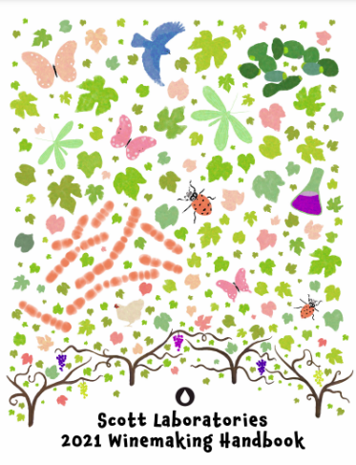

Scott Labs 2021 Winemaking Guide
https://scott-labs-static.sfo3.cdn.digitaloceanspaces.com/legacy-guide-pdfs/Scott-2021-Winemaking-HB-Web.pdf

Lallemand Yeast Quick Guide
https://www.lallemandwine.com/wp-content/uploads/2017/12/Quick-Yeast-References-Chart_2018_LR.pdf

White Labs Wine Yeast and Fermentation Products
https://www.whitelabs.com/product-landing?id=2

Morewinemaking Yeast & Grape Pairing Guide
https://morewinemaking.com/web_files/intranet.morebeer.com/files/wyeastpair.pdf

NOTE: This ODDS & ENDS spot open to members. If you have equipment to sell or give away or just something of interest you would like to share, email it to Steve Brunkhorst for inclusion here.

