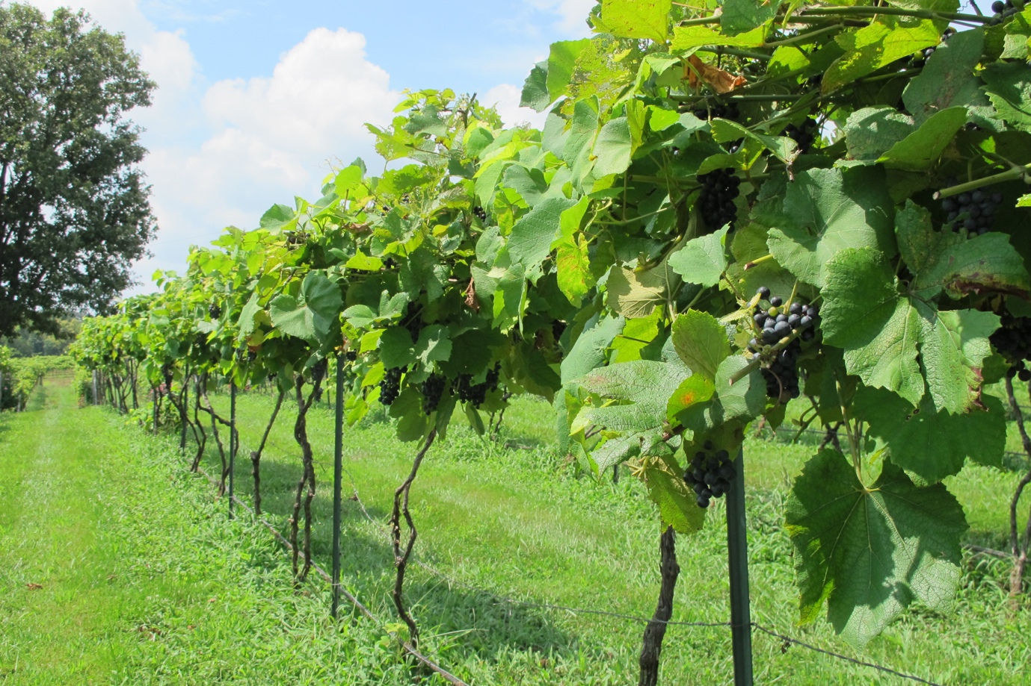

**MISSOURI WINEMAKING SOCIETY MARCH 2024 NEWSLETTER**

**NEXT MEETING: WINEMAKING 101**

**DATE: THURSDAY, MARCH 21**

**WHERE: ST. GERARD MAJELLA MEETING ROOM**

**1971 DOUGHERY FERRY RD.**

**ST. LOUIS, MO 63122**

**TIME: 7:00 PM**

**SUBMITTED BY: Lisa Nordmann**

**MWS WEBSITE:** [**www.mowinemakers.org**](http://www.mowinemakers.org)

**MWS FACEBOOK PAGE**: Missouri Winemaking Society

**MWS INSTAGRAM PAGE**: @mowinemakingsociety

**MISSOURI AMATEUR WINEMAKERS FACEBOOK PAGE**: Missouri Amateur Winemakers

**PRESIDENT’S MESSAGE**: **by Dan Peters**



Sleepy February is in the rear view.  Winter is officially over.  We lose an hour, Daylight Saving time; Ides of March; St Patrick’s Day; Easter; oh and Early Bud Break this year.  Busy, busy, and I’m busy in the cellar, how bout you?  Again, thank you to St. James wine staff and some of you, after back sweetening my ’23 Chardonel, I bottled and ready to enjoy.  I also bottled some delicious peach colored Sangiovese Rose’.  Racking others, cleaning bottles, etc.  In the midst of it all we look forward to hosting some curious, hopeful, future wine makers this month.  Thank you Lisa for your efforts in getting the word out.  I look forward to our group effort in sharing beginner / essential wine making techniques with our guests. Of course, we will share some wine too. See you soon!  Cheers!

**MARCH MEETING: WINEMAKING 101**

Join our March “Winemaking 101” meeting and find out how your basic winemaking techniques compare to those of other members.   **This meeting will be of great interest to both experienced and newer winemakers with plenty of information and ideas for everyone who loves to make wine**.  If you know someone who is interested in winemaking please invite them to this meeting, this is a great opportunity to learn about the process and our members.

This event will be in a ROUNDTABLE format where all attendees will have a voice to contribute and to ask questions. Our meeting moderator will ensure all who want to participate can do so, and to also keep the discussion moving forward.

The meeting will focus on Red Winemaking, and we will follow the process outline of the ***“MoreWine! Guide to Red Winemaking****”.* This text is free online and will serve to both guide the discussion and be a source of reference information before and after the meeting. We will begin with the topic of sourcing fruit and continue with the winemaking process from there.  If we do not discuss all the topics shown in this meeting, and if there is member interest in continuing the discussion, we will follow-up with another session in the future to continue the discussion.

**IF YOU ENTERED A WINE INTO THE NOVEMBER FAVORITE RED CONTEST AND DID NOT HAVE A CHANCE TO TALK ABOUT IT, PLEASE BRING YOUR WINE. WE WOULD LOVE TO HEAR ABOUT YOUR WINEMAKING PROCESS.**

All members are invited to bring one bottle of their home crafted red wine if available (but not required) to share and enjoy.

**FEBRUARY MEETING: MWS MEMBER WINES WIN BIG TIME AT AMERICAN WINE SOCIETY NATIONAL COMPETITION**.

Eight of our members submitted their handcrafted wines to the American Wine Society Competition held in St Louis in November 2023.  AWS Certified Judges tasted wines produced by 124 winemakers from 29 states and recognized the best wines with Gold, Silver and Bronze medals. Our member wines earned 39 medals and our St Louis area winemakers were enthusiastically recognized by winemakers from around the country.

Cris Hehner presented his Silver Medal 2020 Chambourcin and Bronze 2022 Frontenac Gris Rose.’

Lisa Nordmann presented her Silver Medal 2022 Cayuga.

John Merkle presented Silver Medal 2022 Chenin Blanc.

Steve Brunkhorst presented his Silver Medal Seyval Blanc.

Greg Stricker presented his Double Gold Medal 2022 Vignoles and 2020 Silver Chambourcin.

Anne Cath presented her Gold Medal 2020 Syrah.

All the wines were delicious and very worthy of their awards!

**APRIL MEETING: John Merkle will present NORTON WINES AND NORTON WINEMAKING**

The April meeting of the Missouri Winemaking Society will feature a "modified" vertical tasting of Norton wines over many years.  
John Merkle will present 14 different bottles of Norton ranging from 2002 to 2017 from his collection.  
There will be no charge for the wines as they are being donated to the club.  
  
Included will be 4 Nortons from Stone Hill, 2 from Noboleis and various other wineries in Missouri, one from Virginia and three J. Merkle wines.  
John will present a short history of the Norton grape, winemaking techniques with Norton, and tasting of all the wines.  
Please bring 2 glasses and if you have them, Norton glasses.

**CONGRATULATIONS TO GREG STRICKER AND LISA NORDMANN FROM THE AWS**

American Wine Society awarded the top 25 winemakers from (2019-Current).

Point totals are calculated by giving 100 points for each double gold or gold medal, 58 for each silver, and 34 for each bronze. Points have been accumulating since 1975, when their records began.

In the top 25, Greg Stricker came in as #6 with a total of 2,052 points.

In the top 25, Lisa Nordmann came in as #25 with 786 points.

Greg Stricker also was awarded as one of the Top 50 Amateur Winemakers ranking 28th in 2023 with 2,280 accumulative points.

**DANIEL PAMBIANCHI: NEW BOOK AND WEBINARS**

Wine Guru – Daniel Pambianchi just published his new book for Beginning Winemakers. Here is the link to order it. <https://techniquesinhomewinemaking.com/beginners-guide/> It can also be ordered on Amazon. Here is a synopsis of the book.

From the author of *Modern Home Winemaking* and *Techniques in Home Winemaking*, **Daniel Pambianchi’ s** *The Beginner’ s Guide to Making Wine from Juice and Grapes* is for novices keen in making their own wine at home. It guides aspiring winemakers through the process, from crush to bottle, with step-by-step instructions using simple, modern techniques to craft consistently great wine. The book includes many illustrations, tables and examples to highlight the use of equipment and tools, and a comprehensive chapter dedicated to solving common winemaking problems.

Also, Daniel has very informative webinars. They are only $9.95 if you view them live. After the webinar he will answer questions. If you can’t view them live, they are available for $4.95. I have viewed every webinar and have learned so much. His next one is on March 13th on **UNDERSTANDING, MEASURING, AND CONTROLLING RESIDUAL SUGARS.**

**Daniel’s Website is full of information. Check it out at** <https://techniquesinhomewinemaking.com>

**YEARLY DUES ARE DUE**

Our yearly dues of $50 is now due. Please bring a check made out to Missouri Winemaking Society to the January meeting and give it to Dave Wert. You can also mail it in to Dave Wert, 1599 Highway 100, Pacific, MO 63069.

**ENJOY THE PICS FROM OUR FEBRUARY MEETING**

