-MISSOURI WINEMAKING SOCIETY-
-JANUARY 2021 NEWSLETTER-

IN THIS NEWSLETTER:
- JANUARY ZOOM - THIRD THURSDAY AT 7PM
- DUES DUE - SPECIAL COVID RATES
- NEW OFFICERS ELECTED
- MEETING SCHEDULE FOR 2021
- RECAP-DECEMBER 17TH ZOOM CHRISTMAS PARTY

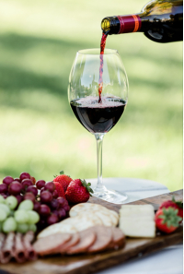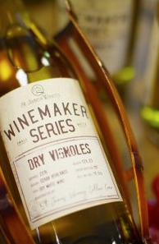
MARK YOUR CALENDAR FOR ZOOMING on Thursday January 21st at 7PM. Our presenter will be Andrew Meggitt, Executive Winemaker, VP Production & President at St James Winery. A native of New Zealand, Andrew has been enjoying life in the wine business for more than 20 years. His life passions include family, running, coaching soccer, camping, hiking, tennis, fishing, and mountain biking. Andrew stretches the boundaries of traditional winemaking, while integrating both old and new world techniques he learned while working in New Zealand and France. St James Winery has been among the Top 4 Gold Medal Awarded Wineries in the USA for the past 8 years. Recent Awards include Best of Show Riesling Finger Lakes International, Double Gold for Pioneer White Finger Lakes International, Best of Show Pacific Rim.
You will find St James wines at most wine stores in the St. Louis area, pick up one or two to taste during this event. As an alternative, you may want to get out of the house and drive to St. James on a sunny January day before the meeting, it is just an hour and a half from West County. At the winery you can enjoy a tasting and find a greater selection of wines including the “Winemaker Series”. In the ZOOM Andrew will be ready to answer winemaking questions from our members, please be prepared with yours. Find more about the winery at https://www.stjameswinery.com/

DUES ARE DUE NOW. If you paid for a $50 membership in 2020, your 2021 dues will be just $15. If you did not pay for a $50 membership in 2020, your 2021 dues will be just $30. Send your check payable to “Missouri Winemaking Society” to Phil Rahn, 511 Kenilworth Ln, Ballwin, MO 63011. Please pay your dues by end of January. Dues Background: 2021 dues have been set to cover only the “fixed costs” of our society since we do not know exactly when we will be able to meet again face to face. In addition, our variable costs in 2020 were less than budgeted due to suspension of meeting and the substitution of ZOOM events, so the remainder of dues not spent in 2020 have been applied to 2021 fixed costs.

OFFICERS FOR 2021 - ELECTED BY MEMBERS ARE: President- Lisa Nordmann, Vice President – John Merkel, Treasurer – Phil Rahn, Secretary – Steve Brunkhorst, Cellarmaster – Dan Peters. Thanks to Dave Wert for many-many years of service as an MWS officer, he leaves office this year and will be able to spend more time in his vineyard. John Merkel rejoins the officer corps this year after a several year sabbatical where he studied wine making and wine consumption.

2021 MEETING SCHEDULE. Please mark your calendar for the 3rd Thursday of each month at 7PM. We will begin the year with a continuation of the ZOOM meetings. We hope that Covid-19 will be under control later in the year and we will be able to resume our meetings at St. Gerard Magella Church. The officers are meeting this month to finalize the schedule for the remainder of the year to be published in the February newsletter and on our website.

THE ANNUAL CHRISTMAS PARTY, held this year as a ZOOM event on Thursday, December 17th was a great success. Lisa & John Nordmann led the wine trivia game “Wine Wars” and the meeting attendees competed for a $25 gift certificate from “The Wine Barrel”. After 3 intensively competitive rounds that separated the “wine-wusses” from the “wine-wizards” Judy Hon emerged as the winner of the competition. Brian Prunty was most attentive during the ZOOM and won the attendance prize, a $25 gift certificate from “The wine & Cheese Place”.

