MISSOURI WINEMAKING SOCIETY
JULY 2021 NEWSLETTER

IN THIS NEWSLETTER:
- Winery Visit & Lunch – Saturday, 7/17 at 11:00 AM
Defiance Ridge Vineyards
- PRESIDENT’S MESSAGE
In Person Once Again
- MEETING SCHEDULE FOR 2021
Meetings return to St Gerard Majella in August
- JUNE MEETING RECAP
Rose’ Project Tasting
- ODDS AND ENDS
Free Seyval Blanc Plants

DEFIANCE RIDGE VINYARD & WINERY TOUR & BISTRO LUNCH:
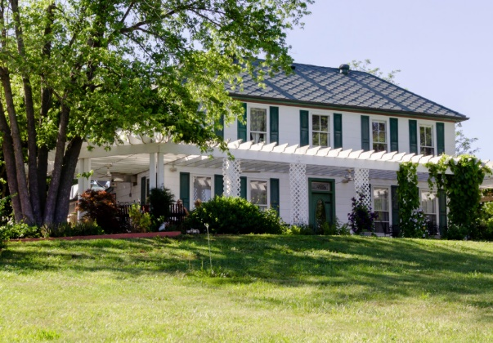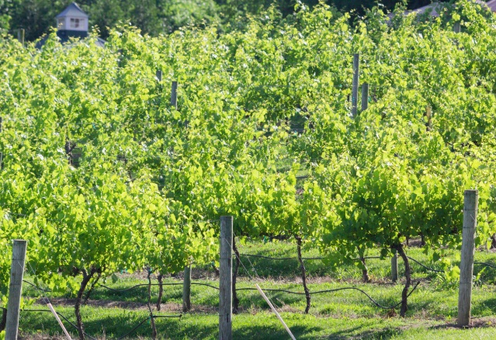
RSVP: PLEASE REPLY TO THIS EMAIL IF YOU WILL ATTEND THE DEFIANCE RIDGE EVENT. THE WINERY NEEDS THIS INPUT TO SET UP OUR PRIVATE EVENT.
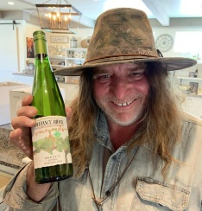
Our July meeting will be SATURDAY JULY 17th beginning at 11:00AM. Defiance Ridge Winery is located at 2711 South MO HWY 94 in Defiance MO. It is just 11 miles and 13 minutes after crossing the Daniel Boone Bridge on I-64. “DRV” is situated on 42 acres in the rolling hills of Historic Missouri Wine Country. The property includes the estate vineyard and winery, an historic farmhouse, and panoramic views of the Missouri River Valley. Veteran winemaker Tom “Murph” Murphy will lead us on a private tour of the vineyard and winery. Afterwards we will enjoy a wine tasting and seated lunch. Each member is responsible for purchase of the wine tasting and lunch. You can have a nice sandwich for about $12 and tasting a flight of wines for $5 to $15 depending on the wines you select. Click on this link to learn all the details about the menu and wine tasting and wine list. https://www.defianceridgevineyards.com/#home-section
Tip: arrive a few minutes early because the tour departs at 11:00AM.

PRESIDENT’S MESSAGE. By Lisa Nordmann
Now that we are meeting in person again, I started to reflect on the importance of our meetings. In our group of winemakers, there is a wealth of information within our club and ripe for the picking. Two years ago, I was having an issue with bitterness in my whites and Rose’s. Steve helped me tremendously with understanding phenols, which can cause astringency in wine and suggested that maybe I was pressing my grapes too hard. I lowered the pressure during press, but unfortunately, I still was getting a bitter aftertaste.
Shortly thereafter at a meeting, I was talking to some members about my dilemma and Bernard out of the blue said, “Have you tried preemptive fining?” Bernard quickly explained how the process works. Greg also joined in on the conversation and told me his preemptive fining process.
I am very thankful for being at that meeting and reaching out to my fellow members for suggestions and answers. I did a lot of research on preemptive fining and that is one process I always do with my whites.
Our in-person meetings are extremely valuable to our winemaking. Each of us has our own way of making wine. When we show up, participate, and share our ideas, it raises all our winemaking skills to a higher level.
Looking forward to seeing everyone at our next meeting!
Cheers! Lisa
2021 MEETING SCHEDULE. Please mark your calendar for the 3rd Thursday of each month at 7PM. Beginning in August we will resume in-person meetings at St. Gerard Majella Catholic Church at 1971 Dougherty Ferry Rd. Check our website for real time updates of the MWS calendar: https://www.mowinemakers.org/
January 21 • 7:00 PM • Speaker • Andrew Meggitt - St. James Winery
February 18• 7:00 PM • Speaker • Kevin Kourofsky • Judge Judy Kelly • Make Better Wine
March 18 • 7:00 PM • Speaker • Hildegarde Heymann, Ph. D. Enologist UC-Davis
April 15 • 7:00 PM • Speaker • Jacob Schneider - Cane Pole Vineyards, LLC
May 20 • 7:00 PM • GADs & GIZs • John Merkle & MWS members
June 17 • 6:30 PM • Lisa & John Nordmann’s Home • Rose’ Winemaking Project
July 17 • 11:00 AM • Defiance Ridge Winery Tour and Picnic • MWS Members • Purchase Wine and Food there.
August 19 • 7:00 PM • Thursday • St. Gerard Majella • Program • Grape growing in Missouri, is Organic Possible? • Presenter • Terry Stromberg
September 16 • 7:00 PM • Thursday • St. Gerard Majella • Favorite White Wine Contest • Leaders • Steve Brunkhorst and Phil Rahn
October 16 • Noon • Saturday • Dave & Debbie Wert’s Home • Annual MWS Picnic • MWS Members Potluck
November 18 • Thursday • 7:00 PM • St. Gerard Majella • Favorite Red Wine Contest • Leaders • Steve Brunkhorst & Phil Rahn
December 11 • Saturday • 7:00 PM • John & Mary Merkle’s Home • Christmas Party • MWS Members Potluck
January 20, 2022 • Thursday • St. Gerard Majella • Missouri Gold Medal Winning Wines
RECAP: THE JUNE 17th MEETING was our first in-person meeting of the year. 10 members brought their hand-crafted Rose’ wines to be tasted by the 17 members in attendance. Thanks to winemakers: Bernard, Chip, Cris, Dan, David, Greg, John, Lisa, Phil, and Steve for sharing their delicious wines. The tasting was conducted in a blind format and tasters voted for their 3 favorite wines. The three “Fav” wines in vote order were produced by Lisa Nordmann, Greg Stricker and Bernard Cleve. A separate email to members will provide more details about the wines in this tasting.

ODDS & ENDS:
FREE for the taking ~75 Seyval Blanc plants. They have been kept in a cooler so they should be fine. Contact Bob Struebing at 618-407-0773.
NOTE: This ODDS & ENDS spot open to members. If you have equipment to sell or give away or just something of interest you would like to share, email it to Steve Brunkhorst for inclusion here.

