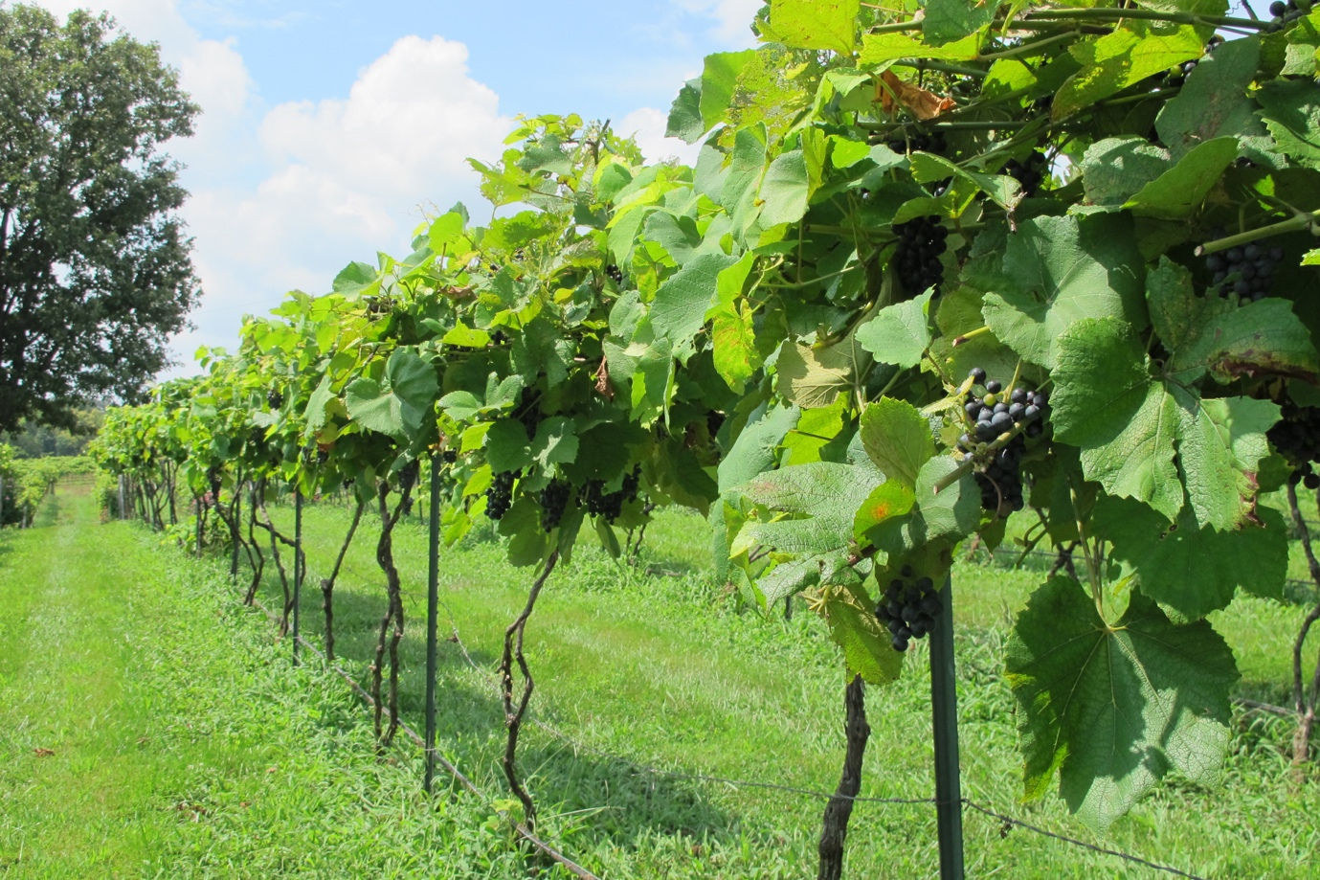

**MISSOURI WINEMAKING SOCIETY JANUARY 2024 NEWSLETTER**

**NEXT MEETING: AWS AWARD WINNER’S WINE TASTING AND WINEMAKER DISCUSSION**

**DATE: THURSDAY, FEBRUARY 15**

**WHERE: ST. GERARD MAJELLA MEETING ROOM**

**1971 DOUGHERY FERRY RD.**

**ST. LOUIS, MO 63122**

**TIME: 7:00 PM**

**MWS WEBSITE:** [**www.mowinemakers.org**](http://www.mowinemakers.org)

**MWS FACEBOOK PAGE**: Missouri Winemaking Society

**MWS INSTAGRAM PAGE**: @mowinemakingsociety

**MISSOURI AMATEUR WINEMAKERS FACEBOOK PAGE**: Missouri Amateur Winemakers

**SUBMITTED BY: Lisa Nordmann**

**PRESIDENT’S MESSAGE**: **by Dan Peters**



Happy February to All   -   It is hard to believe we have already survived the coldest of winter days this year will offer and yet have also already managed so much wine fun to start the year.  We celebrated Missouri Gold in January, will recognize lovers of Red wine in February, and plan on Green in March.  OK you are correct, that was a stretch and does not work, but please admit I attempted to have fun with it.  Correctly stated, we did celebrate Missouri Gold in January, will enjoy the fruits of our members achievements recognized by AWS medal awards in February, and will open the doors in March for all who would like to learn how to make wine or perhaps learn "more" about making wine.  Your officers kicked around terminology for our March meeting and struggled to come up with a catchy word or phrase (you know something better than "wine making for beginners, newbies, young at heart, etc).  The hope is that we will invite those who we know are considering, or might consider, making wine, but just don't know how to get started or would could receive a jolt of confidence by hearing from our experienced wine makers.  So please consider inviting a guest to our March meeting.  Further, our heartfelt thanks go out once again to St. James winery.  Last Friday, many of us had lunch with the St. James wine making staff and they critiqued some of our wines, something like 15 in all.  Their perspective and feedback on our wines was amazing.  Fun Wine Times!  See you soon.

**FEBRUARY MEETING: MWS MEMBER WINES WIN BIG TIME AT AMERICAN WINE SOCIETY NATIONAL COMPETITION**.

Eight of our members submitted their handcrafted wines to the American Wine Society Competition held in St Louis in November 2023.  AWS Certified Judges tasted wines produced by 124 winemakers from 29 states and recognized the best wines with Bronze, Silver and Gold medals. Our member wines earned 39 medals and our St Louis area winemakers were enthusiastically recognized by winemakers from around the country.

Please join us at February meeting and taste a selection of these wines and hear from the winemaker how she or he crafted their medal winning wine. Winemakers will also share the feedback they received from the judges. Once you hear how it was done, you too can be on your way to producing topflight wines in your home winery.

**ST. JAMES CELLAR CREW LUNCH AND DISCUSSION**

Members of Missouri Winemaking Society had a wonderful lunch at Public House Brewery in St. James with the very talented Cellar Crew from St. James Winery. We brought several of our wines made from their juices. They tasted and evaluated our wines. It was very valuable to us amateur winemakers to have professionals evaluate our wines. It was so much fun to meet the crew and their new head winemaker, Aaron. Andrew Meggitt left St. James a few months ago to seek out a new opportunity in Florida. He joined the Lakeridge Winery and Vineyard and St. Sebastian Winery team in Clermont, Florida. He will be missed by all of us but we are so excited for his new adventure. The lunch was enjoyed by all and the feedback from the crew was priceless.

On a side note, for all of us that purchased Vignoles juice in 2023, St. James is also having a hard time making a drinkable wine this year. Kendra, the lab manager explained to us that the Vignoles crop was not at its peak in 2023. The bad weather heavily affected their grape crop. She did share that they were trying to get the acid in check.

**YEARLY DUES ARE DUE**

Our yearly dues of $50 is now due. Please bring a check made out to Missouri Winemaking Society to the January meeting and give it to Dave Wert. You can also mail it in to Dave Wert, 1599 Highway 100, Pacific, MO 63069.

**MARCH MEETING**

Experienced MWS members will share how they make Red Wine. The discussion will be of great interest to both experienced and newer wine makers. This meeting is an opportunity to bring a friend who has an interest in winemaking and wants to learn more.

**ENJOY THE JANUARY MEETING PICS AND OUR VISIT TO ST. JAMES CELLAR CREW LUNCHEON AND WINETASTING**

