-MISSOURI WINEMAKING SOCIETY-
-FEBRUARY 2021 NEWSLETTER-

IN THIS NEWSLETTER:
- FEBRUARY ZOOM - THIRD THURSDAY AT 7PM
- DUES DUE - SPECIAL COVID RATES
- MEETING SCHEDULE FOR 2021
- JANUARY MEETING RECAP
- ODDS AND ENDS – Wine Making Equipment
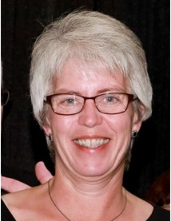
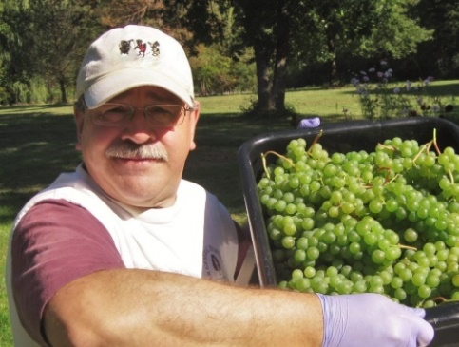
MARK YOUR CALENDAR & JOIN THE ZOOM on Thursday February 18th at 7PM. Our meeting leaders for February hail from Rochester New York, the doorway to the Finger Lakes Wine Region. Wine Judge Judy Kelly and Grape Grower/Winemaker Kevin Kourofsky would like winemakers like us to make better wine. Kevin asked Judy to explain what she looks for when judging, and he took notes which were published in the December edition of the American Wine Society News, available on-line for member of AWS. In our February meeting this discussion will be brought life by the authors.
Open a bottle of your own wine, join the ZOOM and learn how to use your winemaker toolkit to elevate your next vintage wine to the gold medal level.
Judy Kelly is the former Chair of the Rochester, NY chapter of the American Wine Society and currently serves as treasurer. She is an AWS certified wine judge and has completed the Wines and Spirits Educational Trust level 3. Judy has judged as well as volunteered in the back room for several charity-based wine competitions in the Rochester Area as well as Winemaker Magazine’s amateur competition. She is also a member of the Rochester Area Home Winemakers Society (RAHWS), the New York State Home Winemaking Committee, the Society for Wine Education and Women for Winesense. Her passion is learning about wine and helping others to find wines they enjoy.
Kevin Kourofsky is a medal-winning amateur wine maker and grape grower in Rochester, NY, the doorway to the Finger Lakes Wine Region. He is a Certified Specialist in Wine (CSW) from the Society for Wine Education and holds the Advanced Certification, with distinction, from the Wine and Spirits Education Trust (WSET). He can be reached through his blog at Kourofskywine.com.”
DUES ARE DUE NOW. If you paid for a $50 membership in 2020, your 2021 dues are just $15. If you did not pay for a $50 membership in 2020, your 2021 dues will be just $30. Send your check payable to “Missouri Winemaking Society” to Phil Rahn, 511 Kenilworth Ln, Ballwin, MO 63011. Dues were due by end of January but are still being accepted. Dues Background: 2021 dues have been set to cover only the “fixed costs” of our society since we do not know exactly when we will be able to meet again face to face. In addition, our variable costs in 2020 were less than budgeted due to suspension of meeting and the substitution of ZOOM events, so the remainder of dues not spent in 2020 have been applied to 2021 fixed costs.
2021 MEETING SCHEDULE. Please mark your calendar for the 3rd Thursday of each month at 7PM. We will begin the year with a continuation of the ZOOM meetings. We hope that Covid-19 will be under control later in the year and we will be able to resume in person meetings at St. Gerard Magella Church. The officers are working to finalize the schedule for the remainder of the year to be published in the monthly newsletter and on our website: mowinemakers.org
January 21 • 7:00 PM • Speaker • Andrew Meggitt - St. James Winery
February 18• 7:00 PM • Speaker • Kevin Kourofsky • Judge Judy Kelly • Make Better Wine
March 18 • 7:00 PM • Speaker • Hildegarde Heymann, Ph. D. - Enologist
April 15 • 7:00 PM • Speaker • Jacob Schneider - Cane Pole Vineyard
May-December - to be determined due to Covid-19
THE JANUARY MEETING was as a ZOOM event on Thursday, January 21st and received rave reviews by attendees! Our presenter was Andrew Meggitt, Executive Winemaker, VP Production & President at St James Winery. Andrew shared a wide range of information about grape growing, wine making and life as a winemaker and production manager at a commercial winery. Attendees enjoyed their selection of St. James Winery wine and Andrew shared the winemaking approach for each wine. St. James winery has its own fully equipped wine lab with full time lab techs. His recommendation for amateur winemakers working with 5-gallon batches without a lab and staff…sniff you wine each week from fermentation through bottling to catch any trouble as soon as possible and take corrective action.
ODDS & ENDS: CRIS HEHNER REPORTS: “I have done business with Custom Metal Craft over the years and a note in an e-mail caught my eye about small SS wine barrels. I requested a quote which they have sent. Please forward to the wine club.”

ODDS & ENDS: LISA NORDMANN has a table-top corker that needs 1 part, free for the taking. If interested email Lisa at Lnordmann@sbcglobal.net. Also Lisa has 54L demijohn for $35.

