MISSOURI WINEMAKING SOCIETY
AUGUST 2021 NEWSLETTER

IN THIS NEWSLETTER:
- ZOOM ZOOM…winemaking 2021!
Thursday, 8/19 at 7:00 PM
- PRESIDENT’S MESSAGE
Let’s Talk Kit Wines
3) ST JAMES GRAPE JUICE
Reply to Lisa by this Thursday August 5th
- CONGRATULATIONS
Greg Stricker brings home Double-Gold.
- MEETING SCHEDULE FOR 2021
August meeting now a ZOOM
- JUNE MEETING RECAP
Defiance Ridge Vineyard & Winery Visit
- ODDS AND ENDS
Blackberries for Sale & Free Italian…

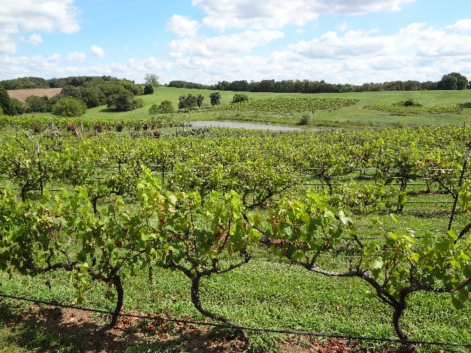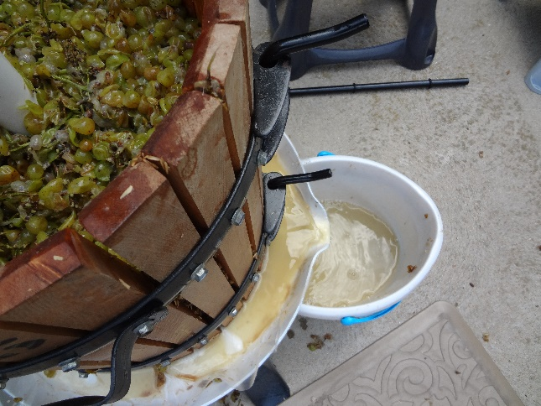

WE WILL ZOOM IN AUGUST. Your MWS officers reviewed the member survey, CDC guidelines, and St. Louis County recommendations to reach this decision. Missouri fruit and grapes will be ready for harvest soon and with this in mind our ZOOM topic will be “Winemaking 2021”. This will be an open discussion among members including the topics of grape and fruit availability, wine making plans and the status of purchase of St. James Winery grape juice.
At the Defiance Ridge Vineyard outdoor event, 23 members completed a survey about future indoor meetings. The survey results indicated that 9 members would not attend indoor meetings if vaccination were not required for attendance and 7 members would not attend indoor meetings if vaccination were required for attendance. The direction from St. Louis Country elected officials is unclear this week with County Executive Sam Page mandating masks for indoor meetings and County Council members voting to overturn the mandate.
The Officers together with Terry Stromberg decided to postpone his presentation on the topic “Grape Growing in Missouri, Is Organic Possible?” until a later date when we can meet in person.
For future meetings, the officers will review the situation each month to determine the meeting location and communicate that in the monthly newsletter. We do have a room reserved at St. Gerard Majella for September 16th if the situation allows an in-person meeting.
PRESIDENT’S MESSAGE. By Lisa Nordmann
LET’S TALK KIT WINES I have made wine from kits. Some good - some not so good. The several WineExpert, Riesling and Chardonnay kit wines I made turned out to be very drinkable wines. A WineExpert Pinot Noir, not so much. I did not degas the wine enough and it was spritzy, not a good quality to have in a red wine. Kit Wines need a lot of degassing to drink early. I also added a WineExpert Cabernet Sauvignon to pressed Chambourcin grapes and that wine turned out rather good.
Last year I was ready to bottle my Chambourcin with good Alcohol, PH, & Tartaric Acid respectable numbers. But the finish on the wine was flat. The taste did not linger in my mouth. I did some research and found that some winemakers add Shiraz to Chambourcin to make a fuller bodied wine.
I went to the store and purchased a commercial Shiraz wine. I added 25% of the commercial Shiraz to 75% Chambourcin. Oh my gosh! I loved it. I had a full bodied Chambourcin wine. But the problem now was that I wanted to enter it into a competition and new that I could not with the addition of a commercial wine.
So, this year I have 10 gallons of Chambourcin ready to be bottled in November. I know I want to add Shiraz to it and hopefully enter it into a competition. I started a WineExpert Shiraz kit and it is smelling delicious! I just can't wait to add this to my Chambourcin for hopefully an award-winning wine. I did use the yeast and bentonite provided in the kit. I did not add the provided oak chips and hope to add an oak stave later for a more controlled oak flavor.
Kit wines are great for new winemakers with detailed instructions on how to make a drinkable wine. Kit wines are also great for the experienced winemaker who want to experiment with the juice provided, many who have won numerous awards in competitions. I will let you all know what category my addition of the Shiraz kit wine to my Chambourcin wine becomes. Drinkable? Award winning? Or down the drain. Time will tell!
Cheers! Lisa
St JAMES WINERY GRAPE JUICE email Lisa by Thursday August 5th
"Members please contact me (Lisa) by this Thursday at lnordmann@sbcglobal.net with your juice order from St. James Winery. We are hoping to get the over 55-gallon price. I think we will get there with the Vignoles and Chardonel juices. Andrew, from St. James Winery would like us to pay with 1 check. I will be responsible for giving him the check. After all the orders are in, I will let you know how much you owe. I will accept checks, Venmo and Pay Pal. I will e-mail you the details of your order as we get closer. Last year the Vignoles was ready at the end of August and the Chardonel was ready at the beginning of September. All members that order will need to go to St. James Winery to pick up your juice on the designated day. Bring sanitized buckets and Andrew will fill them from his tank."
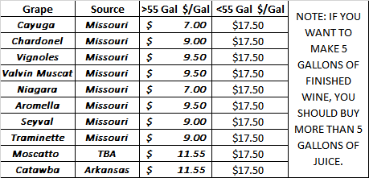

CONGRATULATIONS TO GREG STRICKER! Greg’s wines earned recognition at the New Jersey State Fair. A Gold Medal and Best White Award for his 2019 Riesling, Double Gold for his 2020 Seyval, Gold Medals for his Chardonel, Traminette and White Blend. Also 5 Silver and 2 Bronze. The competition was judged by American Wine Society Certified judges.
2021 MEETING SCHEDULE. Please mark your calendar for the 3rd Thursday of each month at 7PM. The Current plan follows, officers will review the situation each month to determine if in-person or ZOOM meetings will be held. Check our website for real time updates of the MWS calendar: https://www.mowinemakers.org/
January 21 • 7:00 PM • Speaker • Andrew Meggitt - St. James Winery
February 18• 7:00 PM • Speaker • Kevin Kourofsky • Judge Judy Kelly • Make Better Wine
March 18 • 7:00 PM • Speaker • Hildegarde Heymann, Ph. D. Enologist UC-Davis
April 15 • 7:00 PM • Speaker • Jacob Schneider - Cane Pole Vineyards, LLC
May 20 • 7:00 PM • GADs & GIZs • John Merkle & MWS members
June 17 • 6:30 PM • Lisa & John Nordmann’s Home • Rose’ Winemaking Project
July 17 • 11:00 AM • Defiance Ridge Winery Tour and Picnic • MWS Members • Purchase Wine and Food there.
POSTPONED August 19 • 7:00 PM • Thursday • St. Gerard Majella • Program • Grape growing in Missouri, is Organic Possible? • Presenter • Terry Stromberg
August 19 • 7:00 PM • Thursday • ZOOM • Program • Winemaking 2021, grapes, fruit, juice, plans • Presenter Lisa & Officers & Members
September 16 • 7:00 PM • Thursday • St. Gerard Majella • Favorite White Wine Contest • Leaders • Steve Brunkhorst and Phil Rahn
October 16 • Noon • Saturday • Dave & Debbie Wert’s Home • Annual MWS Picnic • MWS Members Potluck
November 18 • Thursday • 7:00 PM • St. Gerard Majella • Favorite Red Wine Contest • Leaders • Steve Brunkhorst & Phil Rahn
December 11 • Saturday • 7:00 PM • John & Mary Merkle’s Home • Christmas Party • MWS Members Potluck
January 20, 2022 • Thursday • St. Gerard Majella • Missouri Gold Medal Winning Wines

RECAP: THE JULY 17th DEFIANCE RIDGE VINEYARD & WINERY VISIT was an informative and enjoyable outing with the extra benefit of a perfect-weather-day. We had 32 attendees comprised of 24 members plus spouses. Winemaker Tom “Murph” Murphy led the group on a tour of the vineyard and the lake and were greeted by “Heath” the resident great white swan. Owner Chuck Gillentine joined us in the winery where we had an eclectic tasting of Missouri wines made from estate grapes and other select local grapes. We then enjoyed lunch together on the open-air porch.

ODDS & ENDS:

MEMBER CHIP BECKER WRITES: Our blackberries will be available well into August. Our price is $1.00/lb. ($.12/oz.) If you pick and $2.00/lb. if we pick ($.25/oz.). I can also make juice in our press for $15/gal. This takes about 15 lbs. of fruit to make a gallon. We have a huge crop this year. So, I am willing to negotiate if someone needs an enormous amount.
Contact for Chip: (217) 313-9634. chip.becker@yahoo.com

FREE THREE LITER DECORATIVE ITALIAN WINE BOTTLES If you would like a large bottle to decorate your wine cellar, please contact me. Think how nice this would look with your own wine label attached. FREE Stevebrunkhorst@outlook.com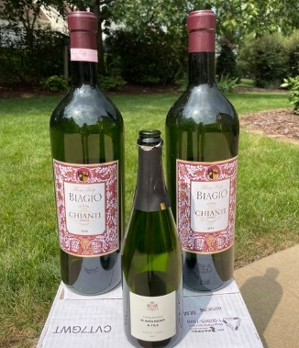

NOTE: This ODDS & ENDS spot open to members. If you have equipment to sell or give away or just something of interest you would like to share, email it to Steve Brunkhorst for inclusion here.

