MISSOURI WINEMAKING SOCIETY
APRIL 2021 NEWSLETTER

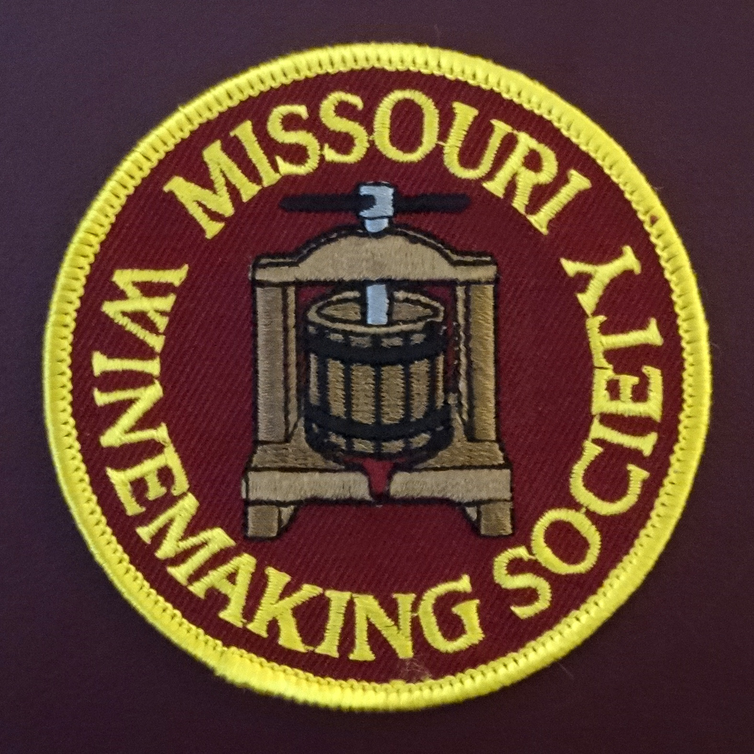

IN THIS NEWSLETTER:
- APRIL ZOOM – Thursday, 4/15 at 7PM
Missouri Winemaker & Grape Grower geared toward Missouri grapes.
- PRESIDENT’S MESSAGE
It takes a village.
- MEETING SCHEDULE FOR 2021
In-person meetings to resume in June (outdoors)
- MARCH MEETING RECAP
Attendees came to their Senses!
- ODDS AND ENDS
Clarity in this Hazy World

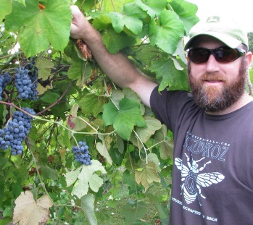
Our April meeting features Missouri Vineyard Owner and Amateur Winemaker Jacob Schneider. Over the years many MWS members have purchased Norton, Chambourcin, Seyval Blanc or Cayuga grapes from Jacob’s Cane Pole Vineyards LLC near Hermann Missouri. Grapes from Jacob’s vineyard are known for their superior quality resulting from the TLC he provides during the year. Jacob is geared up to answer our questions to help our members better manage their vineyards and produce delicious wines from these Missouri grape varieties.
A ZOOM link will be sent to your email address the day before the meeting.
Jacob Schneider
PRESIDENT’S MESSAGE. By Lisa Nordmann
One of the best things about Missouri Winemaking Society is that we can call on any of our fellow winemakers for advice. We have a volunteer list that consists of MWS winemakers specializing in making of certain wines. But sometimes we may be afraid to call our fellow MWS winemakers. I desperately needed help with my Chambourcin Rose’ but felt afraid and intimidated in calling someone. Even though I knew someone on this list could help me, I chose to not bother anyone.
I purchased my grapes from Jacob Schneider (our speaker for April’s Zoom meeting). I knew the grapes were quality grapes. I crushed and destemmed, pressed, settled, and fined my juice. I added all the nutrients especially during fermentation. I took copious notes. I fermented in my Speidel container in a cool wine room at 55 degrees. After fermentation, the lees smelled wonderful and I racked into my carboys, added my SO2 and let it sit for 5 weeks.
When I went to check on my wine after 5 weeks, I thought the smell was going to kill me. It was AWFUL!!! SULPHUR x 100! I had 10 plus gallons of this nasty smelling stuff. I tried everything from splash racking and adding Reduless 3 times (once adding ascorbic acid). The smell was still slightly there. Not as bad but still detectable. It was not drinkable at this point. However, I was determined to salvage this wine.
My first inquiry was to go online. I have so many printed files on sulphur smells in winemaking, a book could be bound. I e-mailed my notes to Jacob Schneider and he responded with some things to look for. We could not figure out what possibly went wrong. Next, I spent $20 to watching a video from Musto Grapes on Sulphur detection during winemaking. I talked with Ralph Rinaldi, winemaker from Musto, and he could not figure out what I did wrong. I called More Wine and they suggested using Copper Sulphate. I started my bench trials.
Then it hit me. Ask someone in MWS. I knew Steve Brunkhorst had experience with using the big guns, Copper Sulphate. He had the same problem with his Chambourcin Rose’ but his was during fermentation. He walked me through what he did and how he salvaged his wine. After applying the Copper Sulphate, the smell was gone but so was the aroma. I also was afraid I had added too much Copper Sulphate, and definitely did not want to poison anyone, but Steve assured me and sent me an article that explained that my doses were within the “safe” region.
I am cold stabilizing my Rose’ now. It is not perfect and may need a little help to bring back the aroma and flavor. I still do not know what I did to cause this problem. I will let you all know next month if we drank or dumped our Chambourcin Rose’.

My point here is IF YOU HAVE A PROBLEM OR NEED SOME INFO - START WITH YOUR FELLOW MWS WINEMAKERS before going through the crazy process I went through. Do not be afraid and do not feel intimidated. We are here to help each other out. I could have saved a lot of time and effort if I had called Steve from the get-go.
2021 MEETING SCHEDULE. Please mark your calendar for the 3rd Thursday of each month at 7PM. ZOOM meetings continue through May, and June will be the first in-person-meeting of the year, outdoors. Indoor in-person-meetings resume in August, see below. Check our website for real time updates of the MWS calendar: https://www.mowinemakers.org/
January 21 • 7:00 PM • Speaker • Andrew Meggitt - St. James Winery
February 18• 7:00 PM • Speaker • Kevin Kourofsky • Judge Judy Kelly • Make Better Wine
March 18 • 7:00 PM • Speaker • Hildegarde Heymann, Ph. D. Enologist UC-Davis
April 15 • 7:00 PM • Speaker • Jacob Schneider - Cane Pole Vineyards, LLC
May 20 • 7:00 PM • Thursday • Program • Gizmos and Gadgets • Presenter • John Merkle & MWS members • via Zoom
June 17 • 6:30 PM • Thursday • Lisa & John Nordmann’s Home • Rose’ Project • Presenter • Steve Brunkhorst
July 17 • 11:00 AM • Defiance Ridge Winery Tour and Picnic • MWS Members • Food allowed.
August 19 • 7:00 PM • Thursday • St. Gerard Majella • Program • Grape growing in Missouri, is Organic Possible? • Presenter • Terry Stromberg
September 16 • 7:00 PM • Thursday • St. Gerard Majella • Favorite White Wine Contest • Presenters • Steve Brunkhorst and Phil Rahn
October 16 • Noon • Saturday • Dave & Debbie Wert’s Home • Annual MWS Picnic • MWS Members Potluck
November 18 • Thursday • 7:00 PM • St. Gerard Majella • Favorite Red Wine Contest • Presenters • Steve Brunkhorst & Phil Rahn
December 11 • Saturday • 7:00 PM • John & Mary Merkle’s Home • Christmas Party • MWS Members Potluck
January 20, 2022 • Thursday • St. Gerard Majella • Missouri Gold Medal Winning Wines •
RECAP: THE MARCH 18th MEETING was as a ZOOM event. Dr. Hildegarde Heymann, Ph.D, Distinguished Professor of Sensory Science in the Department of Viticulture and Enology, UC-Davis presented fascinating information on sensory perception of wines. Dr. Heymann’s power-point is posted in the “Files” tab of our MWS website. Thank you Dr. Heymann.
ODDS & ENDS: If you attended our February ZOOM with Kevin Kourofsky, you remember the lively discussion on the topic of fining. Kevin has posted a new article on fining on his blog titled “Clarity in a hazy world. Make your wine shine. Use this link to find the article:
https://kourofskywine.wordpress.com/2021/02/28/clarity-in-a-hazy-world-make-your-wine-shine/#more-237

NOTE: This ODDS & ENDS spot open to members. If you have equipment to sell or give away or just something of interest you would like to share, email it to Steve Brunkhorst for inclusion here.

